**1.Junit Basic Testing**

**Exercise 1: Setting Up Junit**

**Code:**

**package** Test;

**public** **class** UnitTesting {

**boolean** checkEvenOdd(**int** num) {

**if**(num%2==0) **return** **true**;

**return** **false**;

}

}

**Unit tests creation and output:**

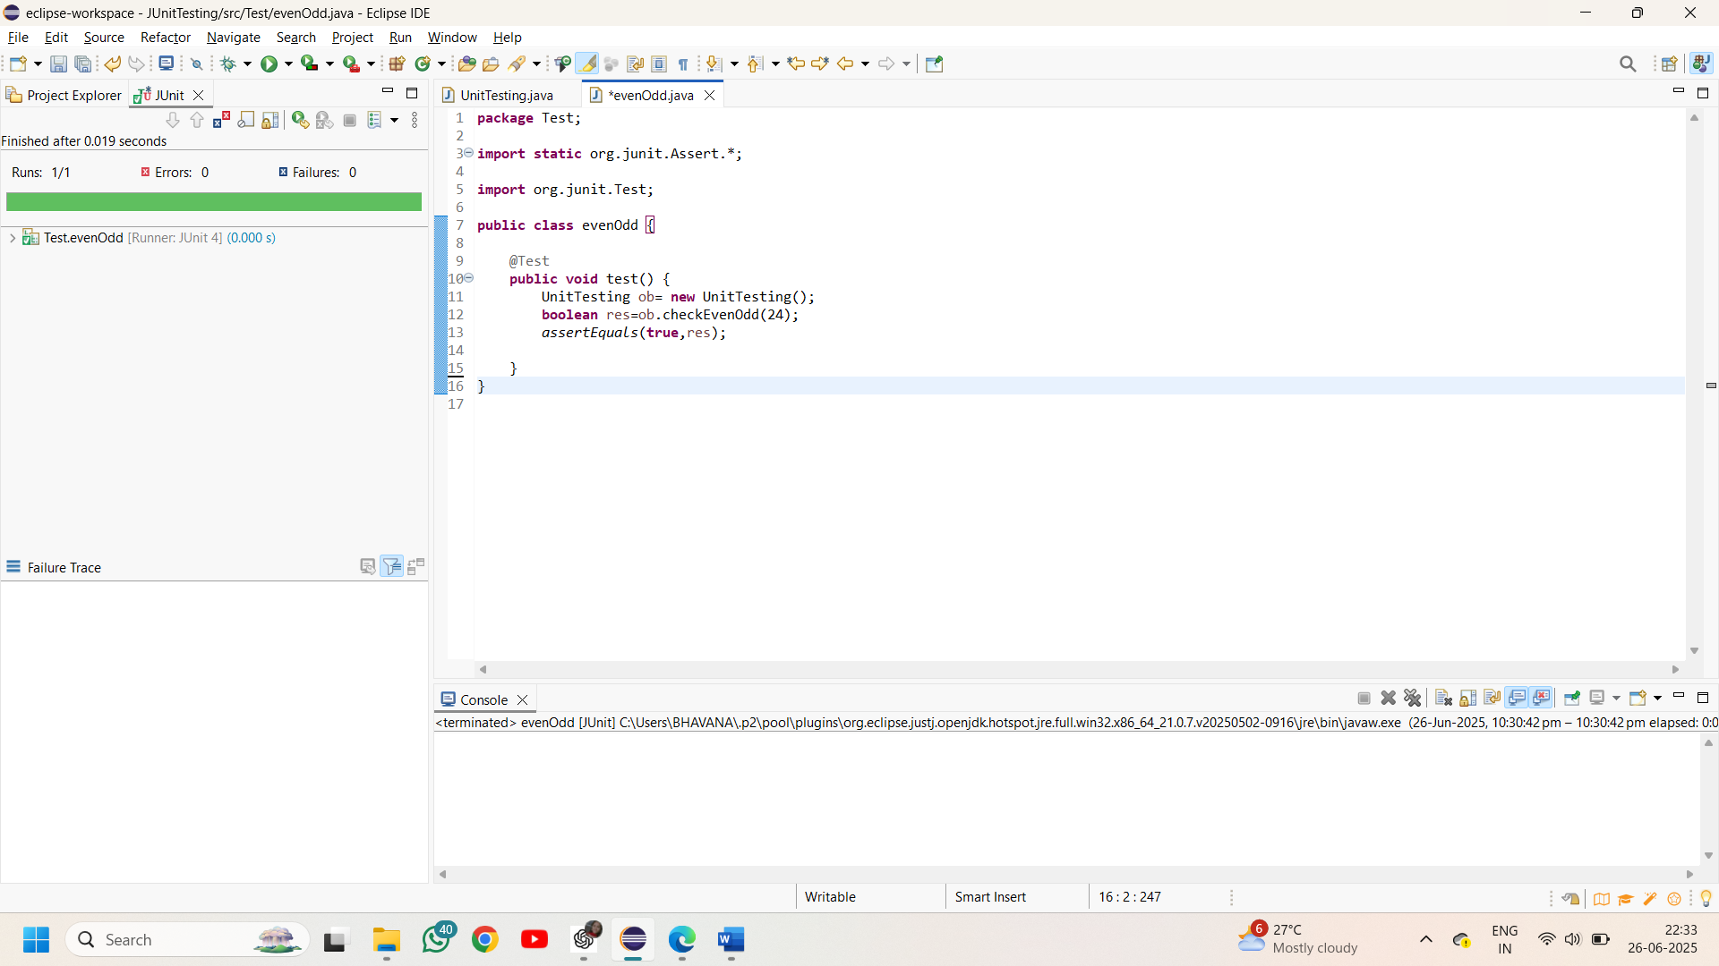

**Exercise 2: Writing Basic JUnit Tests**

**Code:**

**package** tests;

**public** **class** Calculate {

**int** add(**int** a,**int** b) {

**return** a+b;

}

**int** subtract(**int** a,**int** b) {

**return** a-b;

}

**int** multiply(**int** a,**int** b) {

**return** a*b;

}

**int** divide(**int** a,**int** b) {

**if**(b==0) **throw** **new** IllegalArgumentException("division is not possible");

**return** a/b;

}

}

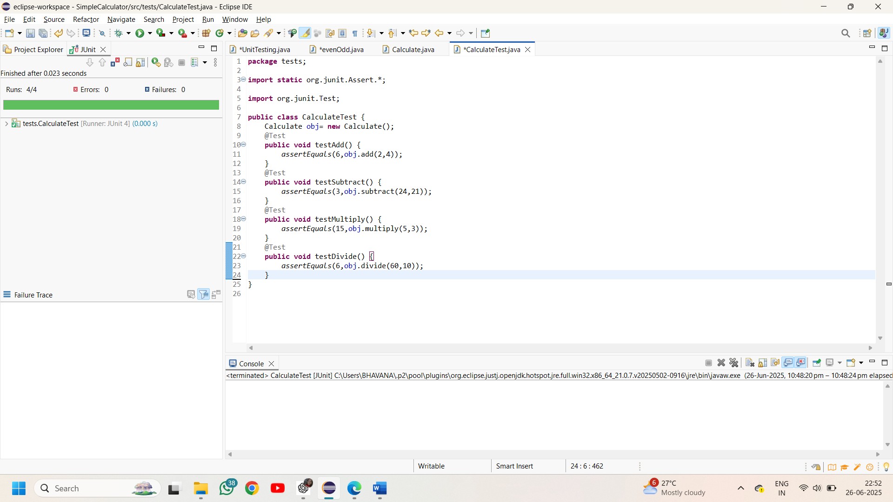**Junit tests and output:**

**Exercise 3: Assertions in Junit**

**Code:**

**package** tests;

**import** **static** org.junit.Assert.*;

**import** org.junit.Test;

**public** **class** VariousAssertions {

Calculate obj= **new** Calculate();

@Test

**public** **void** testEquality() {

*assertEquals*(76,obj.multiply(38, 2));

}

@Test

**public** **void** testCondition1() {

*assertTrue*(obj.add(54,7)>60);

}

@Test

**public** **void** testCondition2() {

*assertFalse*(obj.subtract(34, 89)>0);

}

@Test

**public** **void** testNotNull() {

String message="JUnit testing is Modular";

*assertNotNull*(message);

}

@Test

**public** **void** testNull() {

String message=**null**;

*assertNull*(message);

}

@Test

**public** **void** testSameRef() {

String name="Bhavana";

String name2=name;

*assertSame*(name,name2);

}

@Test

**public** **void** testNotSameRef() {

String place1="AndhraPradesh";

String place2="Karnataka";

*assertNotSame*(place1,place2);

}

@Test

**public** **void** testArrays() {

**int** a1[]= {7,15,23};

**int** a2[]= {7,15,23};

*assertArrayEquals*(a1,a2);

}

}

//The above JUnit tests are created on a java project named calculate.java

**Output:**

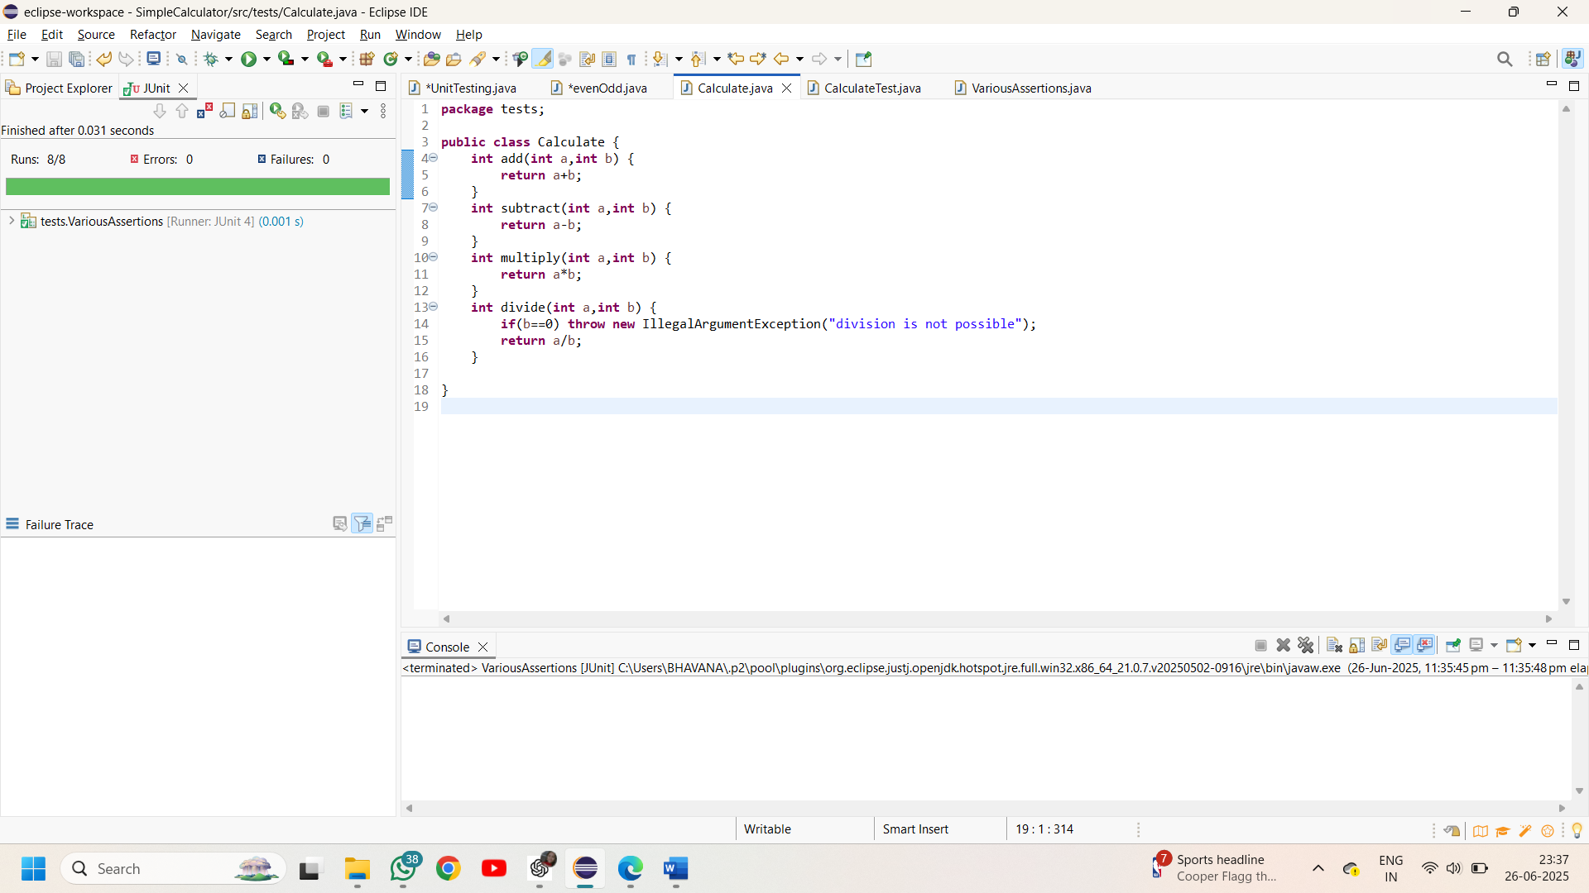

**Exercise 4:**

**Organization of tests using the Arrange-Act-Assert (AAA) pattern and setup, teardown methods.**

**package** tests;

**import** **static** org.junit.Assert.*;

**import** org.junit.*;

**public** **class** AAA {

Calculate obj;

// generally before is to create object as it executes before every test

@Before

**public** **void** setUp() {

System.***out***.println("setting up..");

obj= **new** Calculate();

}

// after is used to clean up the memory

@After

**public** **void** tearDown() {

System.***out***.println("tearing down..");

obj=**null**;

}

@Test

**public** **void** AAA_pattern_add(){

**int** num1=30,num2=12; // arrange

**int** result=obj.add(30, 12); //act

*assertEquals*(42,result); //assert

}

@Test

**public** **void** AAA_pattern_subtract(){

**int** num1=76,num2=16; // arrange

**int** result=obj.subtract(76, 16); //act

*assertEquals*(60,result); //assert

}

}

